First Grade Reading Skills

Main Idea and Details | Cause and Effect
Main Idea: What is the story mostly about?  Details: Facts/evidence that support the main idea.  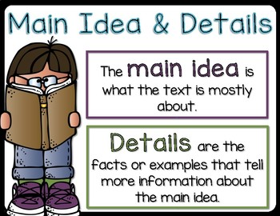 | Cause: Why something happened.  Effect: What happened as a result?  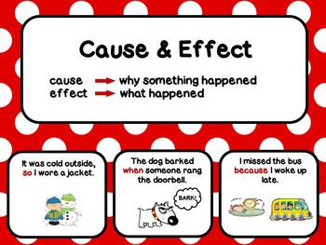
Compare and Contrast | Author’s Purpose
Finding similarities and differences between different things, books, characters, etc. and comparing them. A Venn Diagram is one way to organize this information.  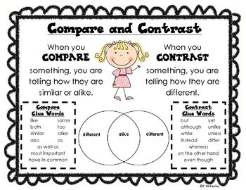 | Authors write stories for many reasons. Was the author’s purpose to persuade, inform, or entertain?  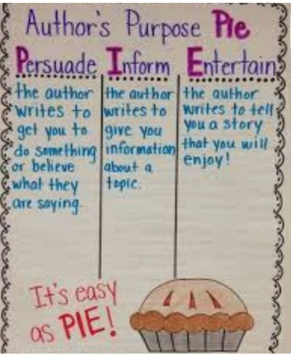
Making Predictions | Inferencing
Prediction: A guess made using text/picture clues.  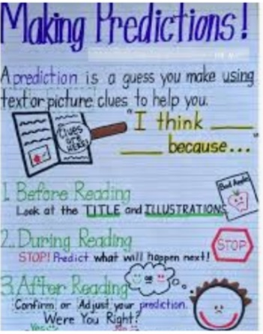 | Using what you have read to learn more than the author specifically states.  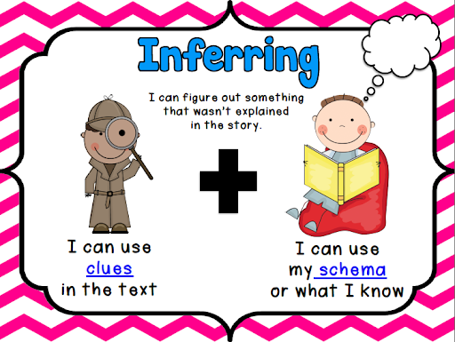
Fact and Opinion
Fact:  A true statement that can be proven. | Opinion:  A Statement stating what someone thinks or feels.

